The Gravitational Force Worksheet

**Course:** “Defy”ning Gravity

**Materials:** Access to **PhET’s “Gravity Force Lab (Basics)” Simulation**, a pencil, your imagination 🚀

**Created by:** Ryan Saelens

0ba2f374-d46b-477c-aa6a-d084dec15ce5.png

During this lesson, **you will be asked to do the following:**

* Run the simulation
* Complete activities
* Summarize findings
* Answer questions

Learning Goals:

* **Gain** an introduction to **Newton’s Laws of Motion** and his **Law of Universal Gravitation**
* **Explore** how **gravity** works between **two objects**
* **Observe** how **mass and distance influence gravity**

Quick Vocab:

**Distance** – How **far apart** two objects are.

**Gravity** - A force that **pulls objects** with mass toward each other.

**Force**- something that can either **push objects or pull objects**

**Mass** - How much **“stuff”** is in an object.

**Newton (N)** – A **unit** of force.

**Inverse Relationship** – When **one thing increases**, the **other decreases**

**Variable** – Something that **can be changed**. Think of a container--**you can choose** what goes inside and how much)

**Independent Variable** – A variable that **can be changed,** though it **isn’t affected by other changes** made in an experiment. These are **the variables that get manipulated.**

**Dependent Variable** - A variable that **changes because of changes made to independent variables.** These are **the variables that offer change, that we can observe and measure.**

Before you begin, remember to **HAVE FUN!** After all, **you’re learning about one of the craziest, coolest topics in all the Universe!**

A QUICK STORY

The gravitational force was discovered by **Sir Issac Newton** after he witnessed **an apple fall down to Earth from a tree**. From this, he thought about **the planets and our Sun above**, and how **they too have mass** like the apple, though a lot more **(since planets are much larger than apples).** From this he obtained his **three laws of motion:**

* **#1** An object **at rest will stay at rest**, until **acted on by an external force**, and an object **in motion will stay in motion** until (also) **acted on by an external force**
* **#2** The force an object has is a **product of its mass and acceleration** 
  + **(F = ma)**
* **#3** Every action has an **equal and opposite reaction**

**Though, only the 3rd law is of importance for this lesson.** I simply state these laws because **the earlier you learn them the better.**

**So now, what is GRAVITY?** Well, **gravity is one of the four fundamental forces in the Universe**, with the others being the electromagnetic force, the strong force, and the weak force. We won’t necessarily address these other forces in this course, though, **just like Newton’s Laws**, it’s good to get an understanding of the four fundamental forces early on. **Gravity is a “pull-force”**, that is, **an attractive force. It brings objects with mass together rather than pushes them apart.**

**To word it like Newton:** TheGravitational force between two objects is **proportional** (a multiplication term) **to the product of the masses of the objects, and inversely proportional** (a term for division) **to the distance between them, squared**.

**A VERY FANCY WAY OF SAYING:** The **greater an object’s mass**, the **greater the gravitational pull**. This force also becomes **stronger as the distance** between two objects **decreases.**

You should now have the tools needed to **begin the simulation** and start your investigation! **Best of luck to you!**

Module 1: Opening the Simulation

To **access/open** the **PhET simulation Gravity Force Lab (Basics)**, click [**HERE!**](https://phet.colorado.edu/sims/html/gravity-force-lab-basics/latest/gravity-force-lab-basics_all.html)

* You should see a blue and a red sphere – each of them look like they’re being pulled by human-like figures.
  + You should also see a few gray boxes with information inside each of them.
* Now that you have the simulation open, continue to the next module to learn the layout and controls!

Module 2: Learning the Layout

We will now go over the different components of the simulation!

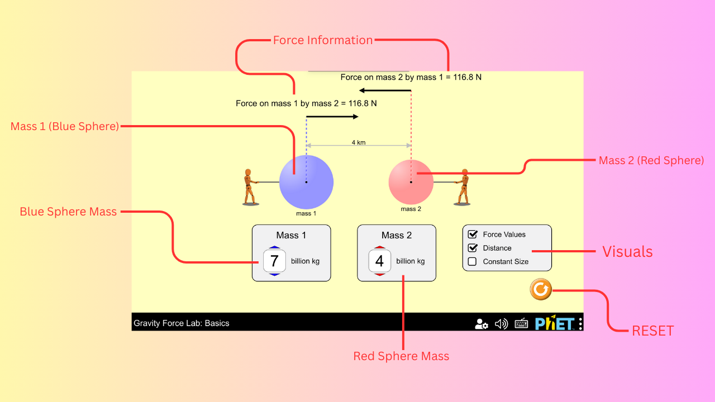

1. **The Center Display** 
   1. A blue sphere (left) and a red sphere (right)
      1. Both have lines that go up to black arrows, pointing at each other
      2. **CLICK AND HOLD** each sphere to change its distance!
2. **Mass1 and Mass2 Boxes** 
   1. Use the up and down arrows in the boxes to change the mass of the spheres – **BE SURE** you’re changing the right sphere!
3. **Visuals Box** 
   1. Distance can be turned on/off ⟶ **CHECK THE BO**X, so it’s on.
   2. Force Values can also be turned on/off ⟶ **CHECK THE BOX**, so this too is turned on.
   3. **DO NOT** check the ‘Constant Size’ box
4. **Above Information** 
   1. These are known as ***force arrows*.**
   2. The numbers shown represent the values for the amount of gravity each sphere has on each other. **Force is measured in Newton’s (N)** – after Sir Issac Newton of course!

Now, take a minute to mess around with the simulation. **Note a few observed changes below (or in your notebook):**

Module 3: The Experiment

Before you begin, remember to have ***Distance* and *Force Values*** **CHECKED!**

* Before you make any changes, record the following values:
  + Write down the **starting mass of the blue sphere.**
  + Write down the **starting mass of the red sphere.**
  + Write down the **distance between the spheres.**
  + Write down the **amount of force each sphere has on each other** (HINT: they should be the same – Newton’s 3rd Law!)
* Next, using the up/down arrows in the Mass 1 Box, **set the mass of the blue sphere (left) to 8 billion kg.** 
  + Then **set the mass of the red sphere (right) to 2 billion kg**, using the Mass 2 Box. **See below.**

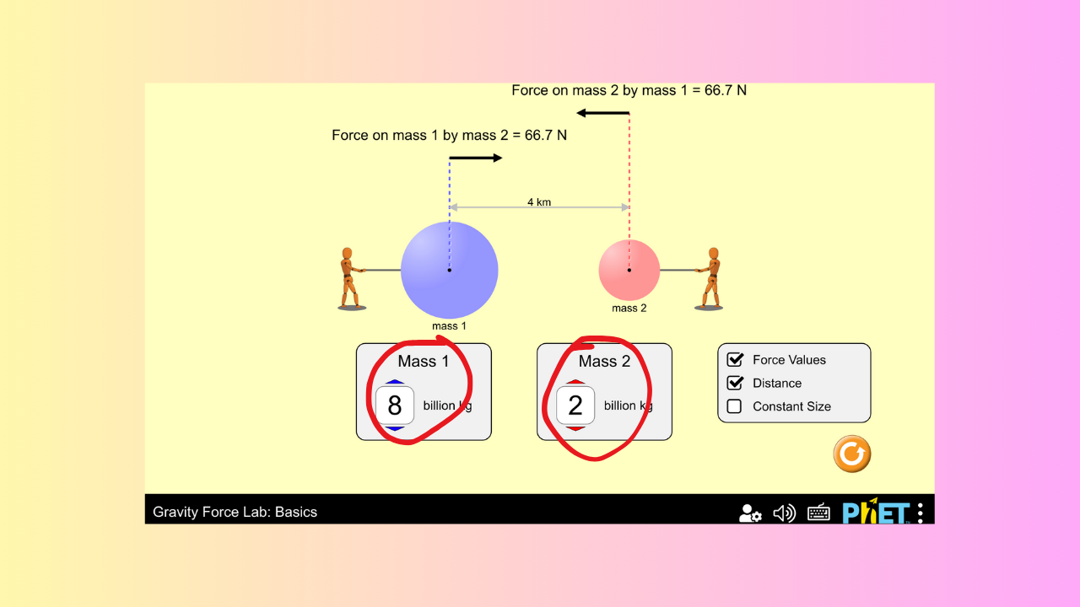

* Record any changes you see **below:**
* Now, **CLICK AND HOLD** to **drag** the blue sphere to the left **until the distance reaches 6km.** 
  + What changes occurred?
  + **Record your results below:**
* Now, pull the red sphere to the right **until the distance reaches 7.2 km.** 
  + What changes occurred?
  + **Record your results below:**
* **RESET** the simulation!
* **Set the mass for both spheres to 9 billion kg.**

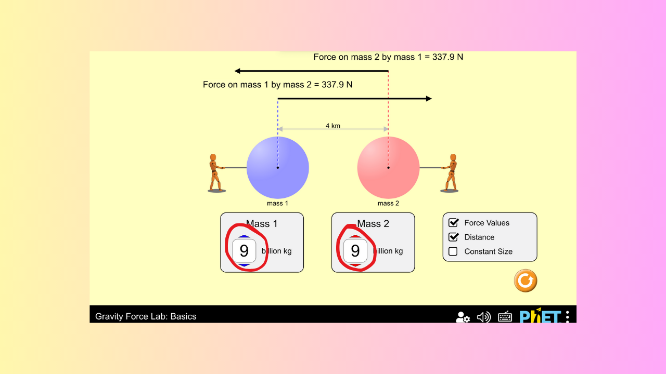

* What changed?
  + **Record your results below:**
* Keeping the mass of the spheres at 9 billion kg, **click and drag the blue sphere until the distance reaches 6.4km.**

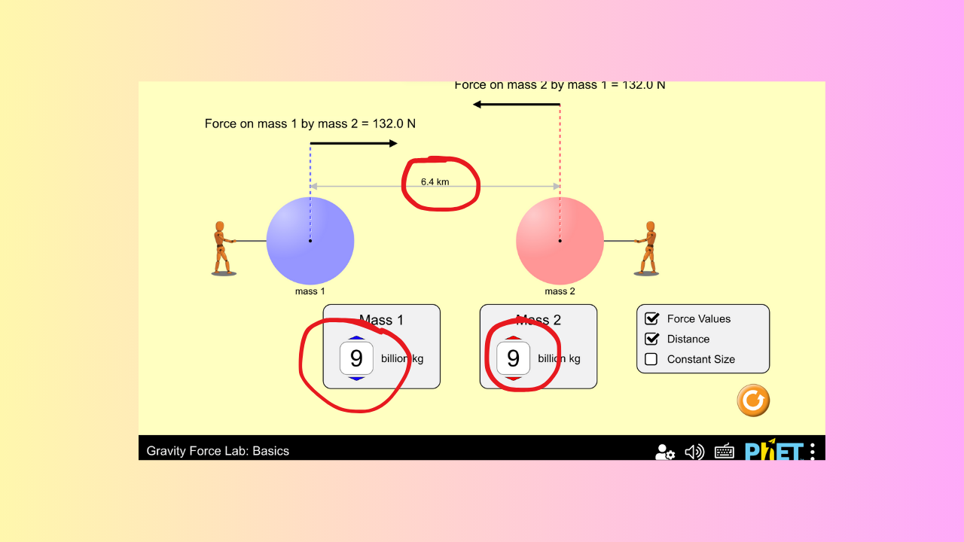

* **Record any changes that you observe below:**

Model 4: Activity A (Blue Sphere)

Before you begin, remember to have *Distance* and *Force Values* **CHECKED!**

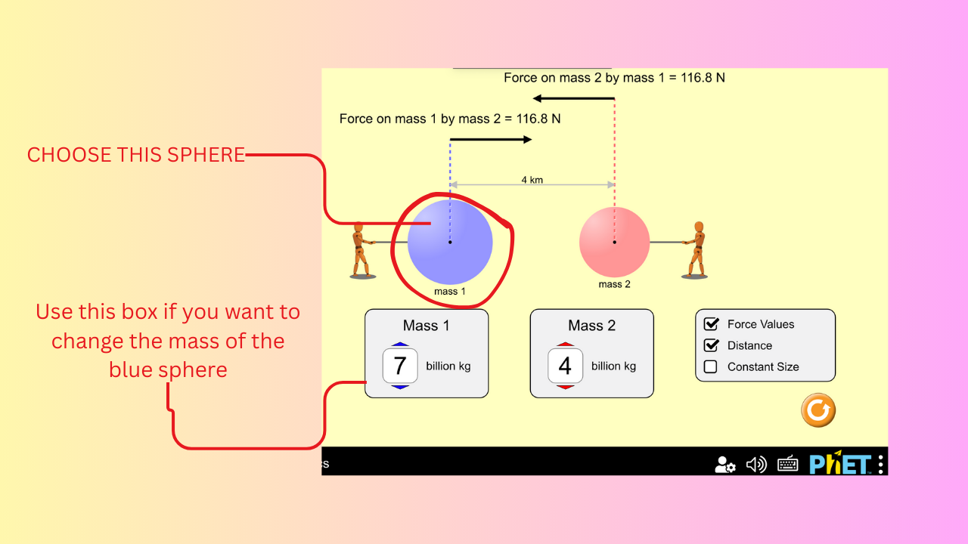

* Now, begin by **manipulating the blue sphere (left)** – this is Mass 1.
  + Label this on your page as **Trial #1 Blue Sphere**
* Note what changes you made to the sphere.
  + Did you **change the mass of sphere?**
  + Did you **change the distance?** 
    - If you did change the distance, **did you pull it further away or closer to the other sphere?**
  + **Were there any other changes** that you noticed, because of manipulating the blue sphere?

Model 5: Activity B (Red Sphere)

Before you begin, remember to have *Distance* and *Force Values* CHECKED!

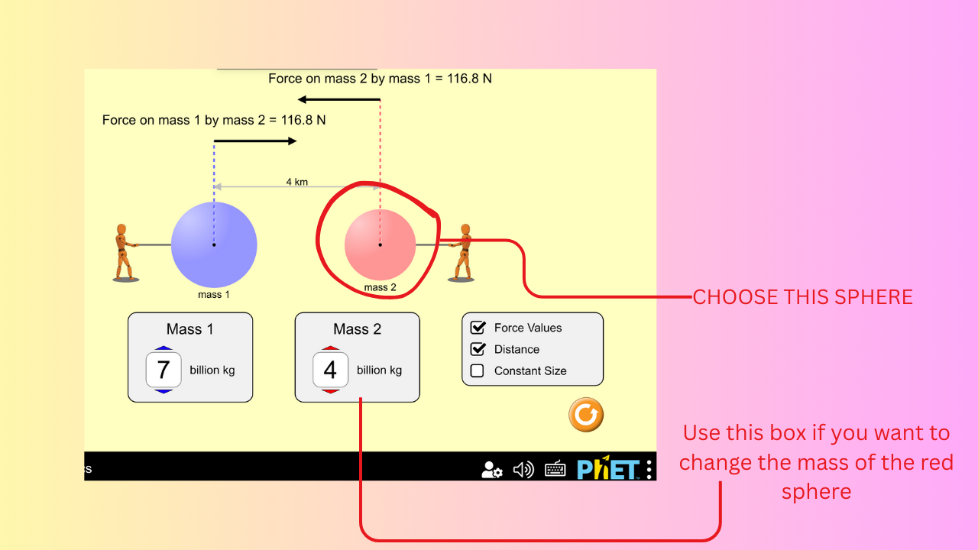

* Now you will **manipulate the red sphere (right)** – this is Mass 2.
* Label this on your page as **Trial #2 Red Sphere**
* Like before, note what you did to change the sphere.
  + Start by **performing the same things to this sphere** that you did to the other one.
  + You can also **change something that you didn’t change last time** 
    - This is **HIGHLY ENCOURAGED!**
* Take a few minutes and compare the results (the notes you took) of **Trial #1** and **Trial #2.** 
  + What was the same? **What was different?**
  + What happens if you **RESET** the simulation and **CHECK** the ‘Constant Size’ box?

Model 6: Answer Questions (T/F)

Please answer the following **True/False questions:**

1. Gravity is a “push-force”.
2. Gravity is something that we observe as **an effect of two objects with mass interacting.**
3. A small object has **more gravity** than a large object.
4. Changing the distance between two objects **won’t change the amount of gravity** they feel.
5. Every action has an equal and opposite reaction.

Model 7: Short Answer Questions

Please answer the following **short answer questions:**

1. In the experiment, **is gravity a dependent or an independent variable?** 
   1. **Why** do you think this?
2. Gravity is affected by what variables in the experiment? **Please list all that apply.**
3. If both spheres **have the same mass**, and they’re roughly **5km** apart, but then **get pulled back** until they are roughly **8km** apart, does the **gravitational force** between them **strengthen or weaken?** **Please explain.**

Up Next: Lesson 2 – Gravity & Orbits!